**Module-6: Assignment-3**

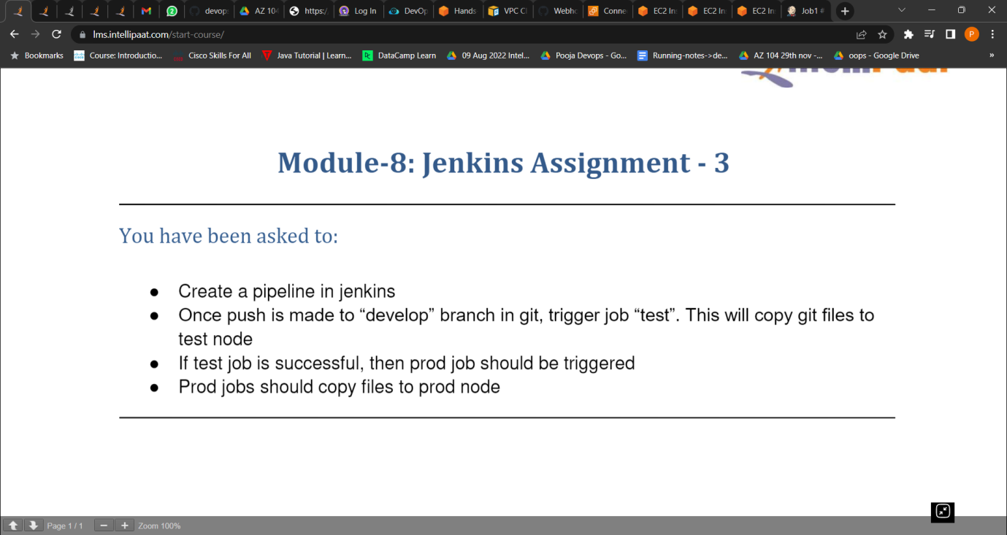

1. Create a pipeline in Jenkins.

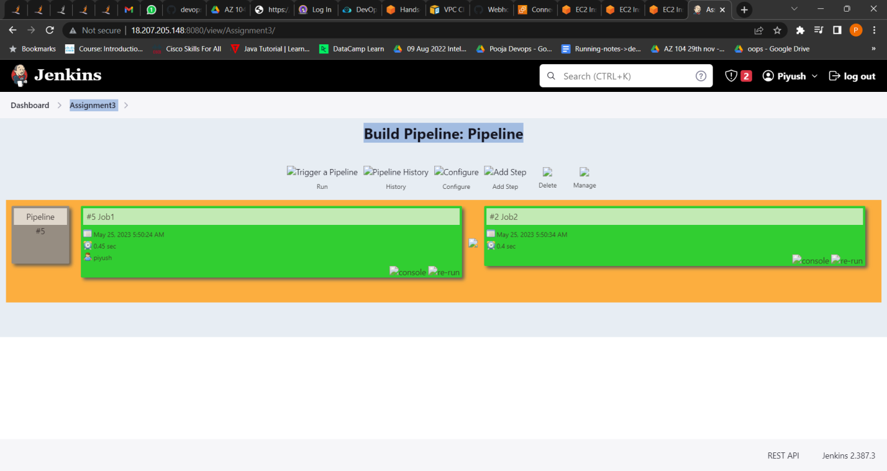

1. Once push is made to “develop” branch in git, trigger job “test”. This will copy git files to test node.
2. If test job is successful, then prod job should be triggered

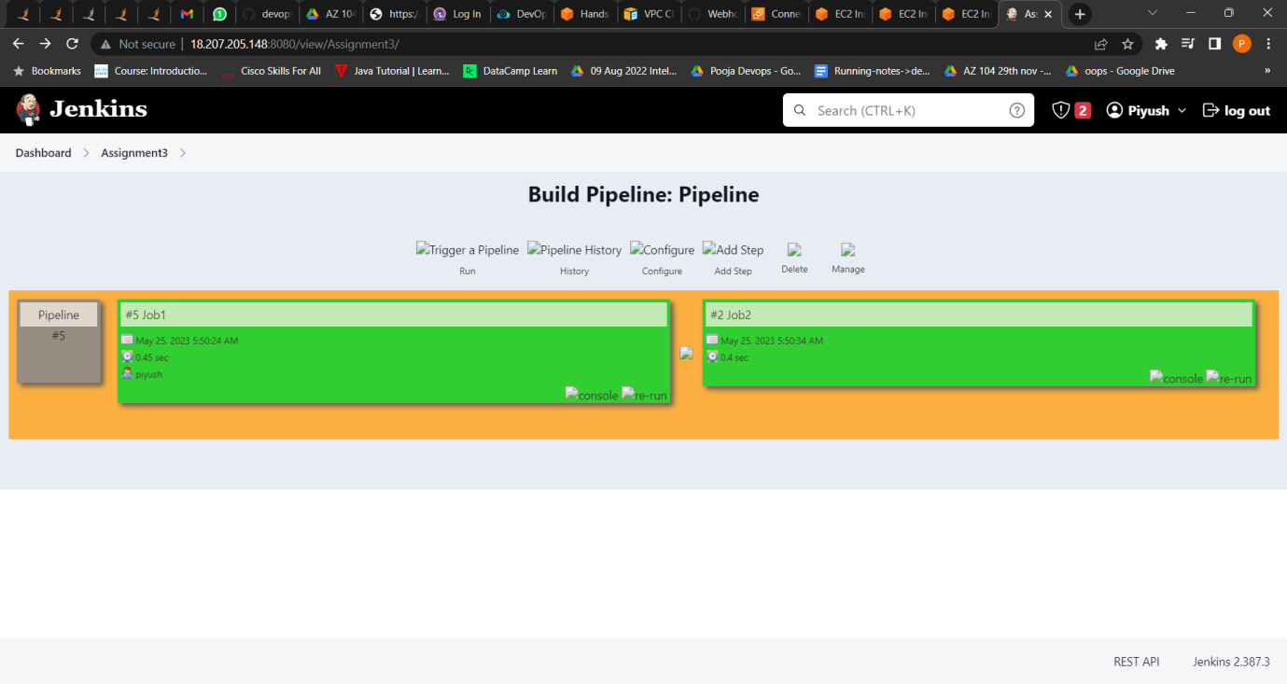

1. Prod jobs should copy files to prod node.



